HANOI SCHOOL OF BUSINESS & MANAGEMENT
Vietnam National University, Hanoi



FINAL REPORT

Team name: Group 4

Team members:
Hoang Le Duy – 23080025
Đoan Hoang Anh – 22080003
Ngo Tai Anh – 23080003
Pham Viet Anh – 23080011
Nguyen Tien Hung – 21080038
Hoàng Ky Anh – 23080002

Topic: A Multi-Tenant Gym Management and Community Platform

Lecturer: Dr. Ngo Trung Kien
Dr. Vuong Thi Nhung
Course: Programming and Application of Information Technology in business

Date: 21/08/2026

Mục lục
List of Figures 3
List of Tables 3
Executive Summary 4
1. Business Problem and Project Background 5
1.1 Business Problem 5
1.2 Project Objectives 5
1.3 Proposed Solution 5
1.4 Project Scope 5
1.5 Users and Roles 6
1.6 Assumptions 6
1.7 Limitations 7
2. Requirements Analysis 8
2.1 Functional Requirements 8
2.2 Non-functional Requirements 9
2.3 User Stories 9
2.4 Acceptance Criteria 10
2.5 Project Board 10
2.6 Team Member Contributions 10
3. System Analysis and Design 12
3.1 Use Case Diagram 12
3.2 Activity Diagram 14
3.3 Sequence Diagram 16
3.4 Application Architecture 18
3.5 Multi-Tenant Architecture 18
3.6 Technology Stack 18
4. Database Design 20
4.1 Database Overview 20
4.2 Database Schema (ERD) 20
4.3 Data Dictionary 20
4.4 Main Relationships 25
5. Application Development and Implementation 26
5.1 Authentication and Authorisation 26
5.2 Member and Membership Management 26
5.3 Package and Promotion Management 26
5.4 Payment and Invoice Workflow 26
5.5 QR Check-in 27
5.6 Schedule and Class Booking 27
5.7 Trainer Tools and Member Progress 27
5.8 Community 27
5.9 Notifications and Reviews 27
5.10 Equipment and Maintenance 27
5.11 Dashboards and Reports 28
6. UI/UX Design 29
6.1 Design Approach 29
6.2 Member and Trainer Interface 29
6.3 Administrator and Manager Interface 29
6.4 Validation, Notifications, and Error Messages 29
7. Security and Data Protection 31
8. Testing and Results 32
8.1 Test Strategy 32
8.2 Test Environment 32
8.3 Test Cases and Results 32
8.4 Security and Tenant Isolation Tests 33
8.5 Problems Found During Testing 33
8.6 Unresolved Defects 33
9. Installation, Deployment and Project Management 35
9.1 Installation Guide 35
9.2 Test Accounts 35
9.3 GitHub Repository 35
9.4 Project Management and Git History 35
9.5 Live or Local Application 36
10. Recommendations and Future Development 37
10.1 Already Implemented 37
10.2 Interface Improvements in Progress 37
10.3 Deepening Existing Business Flows 37
10.4 Proposed New Features 37
10.5 Outside the Scope of This Version 38
11. Project Reflection 39
12. Conclusion 40
13. References 41
14. AI and Tool-Use Declaration 43

List of Figures
Figure 1. The five actors of the GymHub system
Figure 2a. Activity diagram, part 1: create membership, pay, confirm payment
Figure 2b. Activity diagram, part 2: generate invoice, QR check-in
Figure 3. Sequence diagram: payment confirmation and QR check-in
Figure 4. Entity-relationship diagram (core tables)

List of Tables
Table 1. User roles and access scope
Table 2. Functional requirement groups
Table 3. Non-functional requirements and how GymHub meets them
Table 4. User stories
Table 5. Acceptance criteria and test evidence
Table 6. Team member contributions
Table 7. Architecture layers
Table 8. Technology stack
Table 9. Key business tables (data dictionary summary)
Table 10. Git milestone tags
Table 11. Security controls
Table 12. Main automated test classes
Table 13. Demo accounts
Table 14. Proposed new features
Table 15. Third-party assets
Table 16. AI / tool-use declaration

Executive Summary
GymHub is a multi-tenant software platform for gyms. Instead of every gym installing its own separate system, GymHub lets several gyms share one application while keeping their data completely apart. A member or an owner from one gym can never see the members, payments, or reports of another gym, because the separation is enforced by the server, not just hidden in the menu.
The project answers a real problem. Many small and medium gyms in Vietnam still track members and payments with paper records or scattered spreadsheets. This makes it hard to know how many members are still active, how much revenue came in this month, or when a piece of equipment is due for maintenance. GymHub replaces these manual habits with one connected system that several gyms can use at the same cost of ownership.
The system supports five roles: platform admin, gym owner, staff, trainer, and member. Each role only sees the data that belongs to its own gym. The core business flow lets a staff member create a membership, generate a VietQR payment code, and confirm the payment after checking the bank transfer manually. Once confirmed, the system activates the membership, creates a PDF invoice, and sends a notification, all inside a single database transaction, so nothing is left half-done if something goes wrong. Members can also check in with a signed QR code, book classes and personal training sessions, track their body measurements, and use an internal community feed.
GymHub is built with Laravel 13, PHP 8.4, and a MySQL or SQLite database, with Blade views styled using Tailwind CSS and small Alpine.js interactions. Development was organised into three milestones over one week, each one pushed to GitHub with its own tag. The result is 214 automated tests, all passing, covering both business rules and, most importantly, cross-tenant data security. The project shows that a small student team can design, build, and test a secure multi-tenant business application within a short, realistic schedule, while leaving a clear and honest list of what is still designed but not yet built.

1. Business Problem and Project Background

1.1 Business Problem
Most small and medium gyms in Vietnam still run their daily operations with paper notebooks, disconnected spreadsheet files, or single-purpose software built for only one location. This creates several practical problems. Member records live in different places and often go out of sync. Renewing a package, collecting payment, and writing an invoice by hand takes time and is easy to get wrong. Owners have no immediate view of revenue, how many members still have an active package, or which equipment is close to its maintenance date. Members, on their side, have no channel to interact with their gym or to follow their own training progress.
Buying and maintaining a separate system for every gym is expensive, especially for a small business. The challenge that shaped this project was to build a single platform that many gyms can share, while keeping every gym's data fully separated and protected. A member or owner from one gym must never be able to see or change data that belongs to another gym, even by accident.
GymHub answers this challenge with a multi-tenant SaaS design: one website serves several gyms, referred to as tenants, and each tenant has its own management area and its own community space. Every user belongs to a specific gym, and the system automatically works out which gym and which role the logged-in user has, then limits what that user can read or change at the backend level, before the page is even rendered.

1.2 Project Objectives
- Build a working multi-tenant SaaS application where tenant isolation is not only designed but proven with automated tests.
- Implement one complete, realistic business workflow end to end: creating a membership, generating a VietQR payment, confirming payment, issuing a PDF invoice, and checking in with a QR code, all handled safely as atomic operations.
- Deliver the project inside a short and realistic three-block schedule, with visible, incremental progress on GitHub rather than one final upload.
- Keep documentation, diagrams, and the report consistent with what the code actually does, and be able to explain and demonstrate every claimed feature.

1.3 Proposed Solution
GymHub is a Laravel-based web application that gyms access through a normal browser, on desktop or mobile. Every business record, from members and packages to payments and equipment, is tagged with the gym it belongs to. A global query scope filters almost all data automatically by this tag, so a gym's staff can only ever query their own gym's records, and any attempt to reach another gym's resource is rejected before it reaches business logic. On top of this isolation layer, GymHub adds a full membership and payment workflow built around Vietnam's common QR bank transfer method (VietQR), plus scheduling, attendance, trainer tools, a community feed, and role-based dashboards.

1.4 Project Scope
The following items are inside the scope of the current version of GymHub:
- Multi-tenant architecture: each gym is an independent tenant, and every business record carries a gym_id that is used for automatic data isolation.
- Full authentication and authorisation for five roles, controlled at both the tenant and the role level.
- Member, package, promotion, and membership management.
- The core business workflow: create membership, generate a VietQR payment, confirm payment as one atomic transaction, issue a PDF invoice, and check in by QR code.
- Class schedules and personal training sessions, booking, attendance, trainers, body measurements, and workout/nutrition plans.
- An internal community feed per gym (posts, comments, reactions, pinned announcements), notifications, reviews and ratings, and equipment with maintenance tracking.
- Role-based dashboards and revenue reporting.
The following items are explicitly outside the scope of the current version:
- Real bank webhook or payment gateway integration. GymHub only generates a correct VietQR code; staff still confirm payment manually after checking the actual bank statement. The system does not simulate an automatic bank notification.
- A native mobile application. The system is a responsive website, not a mobile app.
- Three extension modules that were designed at the database level for schema consistency, but do not have a user interface yet: loyalty point redemption for rewards, staff salary management, and an automatic audit log. These are described further in section 10 as future development, not as finished features.

1.5 Users and Roles
GymHub defines five roles. Access is controlled on the backend through middleware and policy classes, not only by hiding menu items in the interface.
Role | Scope and typical actions
Platform Admin | Manages the whole platform: views combined statistics across all gyms, lists every gym, and can activate or deactivate a gym. Not attached to any single gym.
Gym Owner | Runs one gym end to end: members, packages, promotions, memberships, payments, invoices, schedules, check-in, equipment, community, and the gym's own dashboard and revenue reports.
Staff | Handles daily operations inside one gym: managing members, creating and confirming payments, checking members in, and managing schedules and equipment. Does not see high-level financial reports.
Trainer | Sees the class schedule and the list of members assigned to them only. Records body measurements, builds workout and nutrition plans for assigned members, and can view reviews written about themselves.
Member | Manages their own profile, views their membership and invoices, pays through VietQR, uses their QR check-in code, books or cancels classes, follows their own progress and plans, and interacts with the community feed.

1.6 Assumptions
Staff reconcile VietQR bank transfers manually against the real bank statement; the system does not assume a live banking API is available. All users access GymHub through a web browser on a desktop, tablet, or mobile phone, with no native app assumed. The application is database-agnostic through Laravel's migration system. Local development and the automated test suite both run on SQLite, while the .env.example file is configured for MySQL, which is the database engine assumed for production-style deployment.
Each gym in the demo data operates independently, with its own staff, packages, and members, reflecting how a real multi-gym SaaS customer base would operate.

1.7 Limitations
These are limitations of the current implementation, not planned future work, which is discussed separately in Section 10. Payment confirmation is manual: there is no automatic reconciliation with a real bank feed, so a staff member must check the bank statement before pressing confirm. Invoices can be downloaded as PDF but are not automatically emailed to the member. Community posts and reviews are moderated manually by staff or the owner, with no automated content filter. The interface is Vietnamese-only and is delivered as a responsive website rather than a native mobile application. Three modules, including loyalty point redemption, staff salary management, and an automatic audit log, already have their database tables designed to keep the schema consistent, but they do not yet have working interfaces and therefore cannot be demonstrated.

2. Requirements Analysis

2.1 Functional Requirements
The functional requirements are grouped below into ten related areas instead of being listed as a flat set of codes, so the logic of the system is easier to follow. Every group below maps to real routes, controllers, and service classes in the codebase, referenced again in section 5.

Authentication and tenant access
A visitor can register as a member, which requires choosing a gym at sign-up, then log in, log out, verify their email, and reset or change their password. A disabled account or a deactivated gym is blocked from logging in, and after login the user is redirected to the dashboard that matches their role. Once logged in, every query for business data is automatically filtered to the user's own gym; reaching a resource that belongs to a different gym returns a 403 or 404 response instead of leaking data.

Member, package, and promotion management
Staff and owners can create, edit, search, filter, sort, and soft-delete (with recovery) member records. Searching works by name, email, member code, or phone number. Member codes are generated automatically and stay unique even when several requests happen at the same time. Packages and promotions also have full CRUD, and a promotion can be attached to a package only while it is still within its valid date range.

Membership, payment, and invoicing workflow
Creating a membership means picking a member, a package, and an optional promotion; the final price is computed with PHP's arbitrary-precision bcmath functions so rounding stays exact, and the new membership always starts in a pending state, never active, until payment is confirmed. A payment record is then created together with a VietQR code that encodes the exact amount and a unique transfer reference. When staff confirm that payment, four things happen together inside a single database transaction: the payment becomes paid, the membership becomes active, an invoice is generated, and a notification is created. If any step fails, the whole transaction rolls back, so the system never ends up half-updated, and a payment can never be confirmed twice. The invoice itself is a Vietnamese-language PDF with a unique sequential invoice number, generated with DomPDF and a Unicode-safe font.

Attendance and QR check-in
Every member has a QR code signed with their own secret key. Check-in is rejected if the signature is invalid, if the member's package has expired, if the member's account is blocked, if the member belongs to a different gym, or if the member has already checked in that day. A successful check-in also adds ten loyalty points.

Schedule and class booking
Staff and trainers manage group classes and one-to-one personal training sessions, including capacity, date, time, and trainer assignment. Members book or cancel a class, and booking is rejected when the class is full, when it overlaps another class the member already booked, when the member has no active membership, or when the member has no personal-training sessions left to use.

Trainer tools and member progress
A trainer has a dashboard showing their teaching schedule and the members assigned to them. They can record body measurements, which automatically compute BMI, and build workout and nutrition plans, but only for members who are actually assigned to them; anything outside that scope returns a permission error.

Community
Each gym has its own feed of posts, comments, and reactions, plus pinned announcements, all scoped to that gym only. Staff and owners can moderate content.

Notifications and reviews
A notification bell shows read and unread items triggered by events such as a confirmed payment, a booked class, or an expiring membership. Members can rate their gym or a specific trainer from one to five stars with an optional comment; reviews can be hidden by moderation, and a trainer only ever sees reviews written about themselves.

Equipment and maintenance
Owners and staff manage a list of equipment per gym and log maintenance records. The dashboard flags equipment that is close to its next scheduled maintenance date.

Dashboard and reporting
Each of the five roles has its own dashboard built from real, live numbers rather than static placeholders. Owners additionally see a monthly revenue report broken down by package, always scoped strictly to their own gym.

2.2 Non-functional Requirements
Beyond features, GymHub also has to satisfy a set of quality requirements. The table below summarises how each one is addressed; several of these points are explained again with more technical detail in section 6 (Security).
Requirement | How GymHub addresses it
Security | Passwords are hashed with bcrypt. Laravel's default protections against CSRF, XSS, and SQL injection are used throughout. Authorisation is checked on the backend, tenant data is isolated automatically, multi-step business actions run inside database transactions, and no secret value is committed to the repository.
Data integrity | Foreign key and unique constraints are enforced at the database level. Multi-step writes are atomic. Important tables use soft deletes instead of hard deletes. Sequential codes such as member codes and invoice numbers are generated safely under concurrent requests using row-level locking.
Performance | Indexes are placed on gym_id and on the columns most frequently filtered or searched. Reports are computed through Eloquent and collection methods rather than heavy raw queries, and images and diagrams used in the documentation are compressed.
Maintainability | The codebase follows a layered structure: thin controllers, validation in Form Request classes, business logic in Service classes, and authorisation in Policy classes. Non-obvious decisions are explained with comments in the code.
Usability / UX | The interface uses a modern SaaS layout with a sidebar and a top bar, is responsive across desktop, tablet, and mobile, and is presented entirely in Vietnamese for the target users.
Testability | A suite of 214 automated feature and unit tests runs against a clean, isolated SQLite database for every test, covering business rules as well as tenant-isolation security.

2.3 User Stories
ID | User story
1 | As a gym owner, I want my gym's data to be completely separated from other gyms, so that no other gym can see my members or my revenue.
2 | As staff, I want to create a membership and generate a VietQR code so the member can transfer money, and then confirm the payment myself after checking the bank statement.
3 | As staff, when I confirm a payment, I want the system to activate the package, issue the invoice, and notify the member, or do nothing at all if something fails, so the data is never left in a half-finished state.
4 | As a member, I want a secure QR code so I can check in quickly at the front desk, and I want the system to block me if my package has already expired.
5 | As a member, I want to book a class at my gym, and I want the system to stop me if the class is full or if I already booked another class at the same time.
6 | As a trainer, I want to see and update the progress of only the members assigned to me, not every member of the gym.
7 | As a gym owner, I want to see my own gym's revenue and how many members still have an active package, so I can make decisions.
8 | As the platform admin, I want to see an overview of every gym on the platform and be able to suspend one when necessary.

2.4 Acceptance Criteria
Every acceptance criterion below is backed by at least one automated test, listed in the right-hand column. The full test suite and its results are presented in section 8.
User story | Acceptance criterion | Test evidence
1 | When the owner of gym A opens the URL of a member, payment, invoice, or schedule that belongs to gym B, the server returns 403 or 404 and no data is exposed. | TenantIsolationTest, RoleAccessTest
2 | If invoice generation fails in the middle of the confirmation transaction, the payment stays pending, the membership stays pending, and no invoice or notification is created. | PaymentConfirmationTest
3 | The same payment cannot be confirmed twice; a second confirmation does not create a second invoice. | PaymentConfirmationTest
4 | The QR token never contains a raw ID or personal data, a forged token is rejected, and an expired, blocked, or duplicate-day check-in is rejected. | AttendanceCheckInTest
5 | A booking is rejected when the class is full, when the time overlaps an existing booking, or when the membership is not valid. | ClassBookingTest
6 | A trainer acting on a member who is not assigned to them gets a 403 response; acting on a member from another gym gets a 404 response. | TrainerAssignmentTest
7 | The owner of gym A never sees the revenue of gym B, even when gym B has higher revenue. | DashboardReportsTest
8 | A membership is always created as pending and only becomes active once its payment is confirmed. | MembershipCreationTest, CoreWorkflowEndToEndTest

2.5 Project Board
Day-to-day progress during the three development blocks was tracked mainly through git commit history and the three milestone tags described in section 9, since each block corresponds to one clearly scoped stage of work agreed on before coding started.
[TO BE COMPLETED: insert the link to the GitHub Projects board here, if the team set one up, or state clearly that commit history and tags were used instead of a formal board.]

2.6 Team Member Contributions
Work was split by module, with one member responsible for each area end to end (design, code, and tests), while the whole team reviewed pull requests and prepared the demo together. The table below summarises the split; a separate task-allocation document with full task-by-task detail and code evidence was also prepared for internal use.
Team member | Main modules | Key evidence | Contribution
Hoàng Lê Duy | Project setup, database migrations, multi-tenant isolation (BelongsToGym), authentication and role middleware, GitHub coordination | TenantScopeTest, RoleAccessTest, 3 milestone tags | 100%
Đoàn Hoàng Anh | Member management, packages, promotions, membership creation | MemberManagementTest (8), MembershipCreationTest (11) | 100%
Ngô Tài Anh | VietQR payment, atomic payment confirmation, PDF invoices | PaymentCreationTest (8), PaymentConfirmationTest (7), InvoiceDownloadTest (6) | 100%
Phạm Việt Anh | Schedules and class booking, QR check-in, trainers and body measurements | ScheduleManagementTest + ClassBookingTest (26), AttendanceCheckInTest (13), TrainerAssignmentTest | 100%
Nguyễn Tiến Hưng | Community feed, notifications, reviews, dashboards, reports, equipment, UI system | CommunityFeedTest (19), NotificationTest + ReviewTest (20), DashboardReportsTest (13), EquipmentTest (10) | 100%
Hoàng Kỳ Anh | Automated tests, security review, documentation, demo data, GitHub releases | 214/214 tests passing, TenantIsolationTest (7), full /docs set | 100%

3. System Analysis and Design

3.1 Use Case Diagram
GymHub has five actors, matching the five roles described in section 1.5. Every use case below was checked against a real route, controller, and policy in the codebase, so the diagram reflects the implemented system rather than an earlier plan.
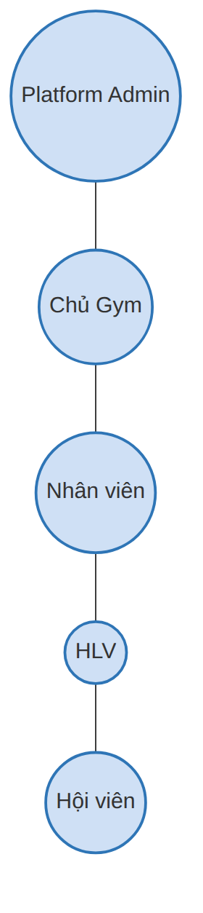
Figure 1. The five actors of the GymHub system

Platform Admin
- View platform-wide statistics (GET /admin)
- List every gym (GET /admin/gyms)
- Activate or deactivate a gym (POST /admin/gyms/{gym}/toggle-active)

Owner and Staff (gym operations)
- Manage members: create, edit, search, filter, soft-delete
- Assign a trainer to a member
- Manage packages and promotions
- Create a membership and its VietQR payment
- Confirm a payment (atomic transaction)
- Download a PDF invoice
- Manage schedules, personal training sessions, and check-in
- Manage equipment and maintenance
- Post to and moderate the community feed

Owner only
- View the gym overview dashboard
- View the monthly revenue and package report

Trainer
- View their teaching schedule and assigned members
- Record body measurements for assigned members
- Build workout and nutrition plans
- View reviews written about themselves

Member
- Register and choose a gym
- View their personal dashboard
- Book or cancel a class
- View their own QR check-in code
- View membership status and download invoices
- Comment, react, and leave reviews
3.2 Activity Diagram
The activity diagram below follows the core business workflow: creating a membership, generating a VietQR payment, confirming that payment as one atomic transaction, generating the invoice, and checking in with a QR code. Every diamond in the diagram is a real branching condition that exists in the code, not a simplification added only for the diagram.
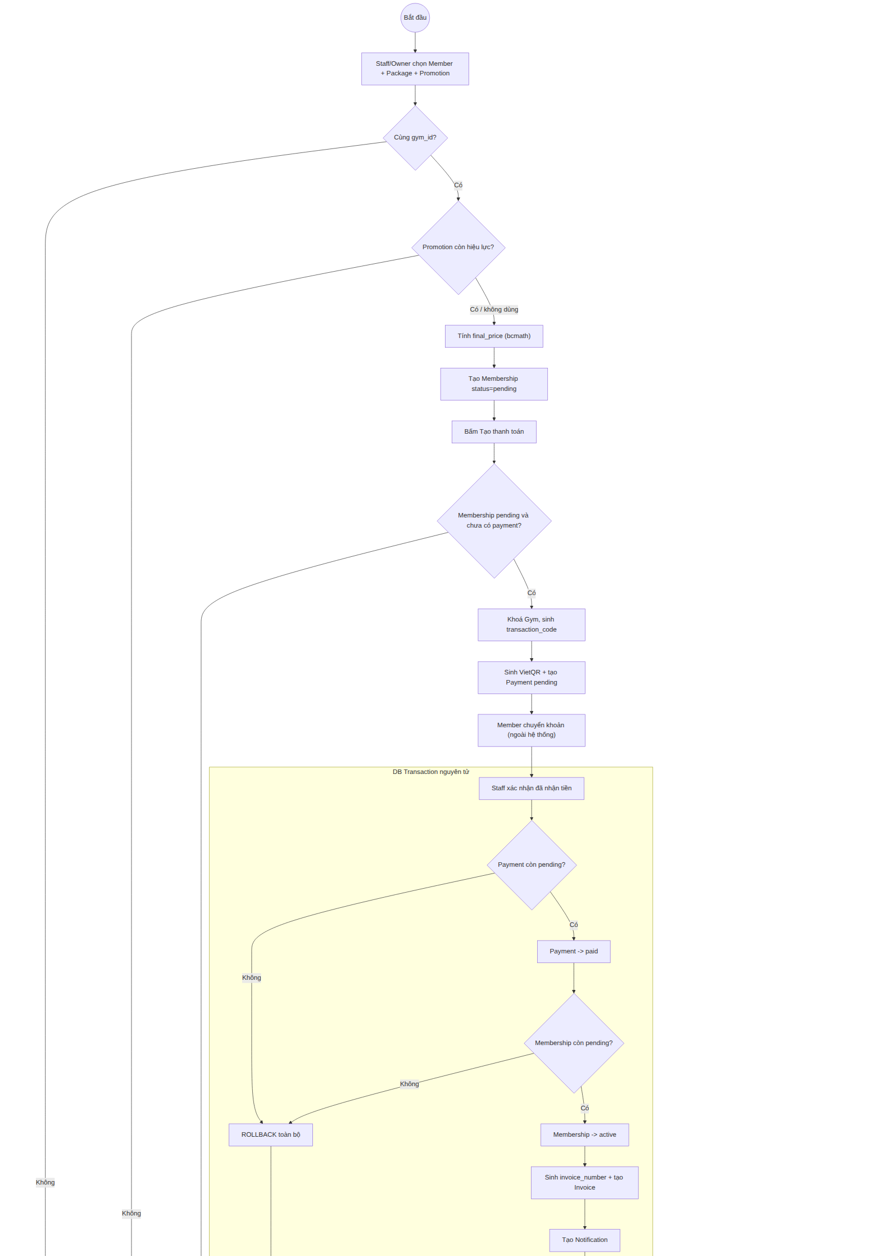
Figure 2a. Activity diagram, part 1: create membership, pay, confirm (atomic transaction)

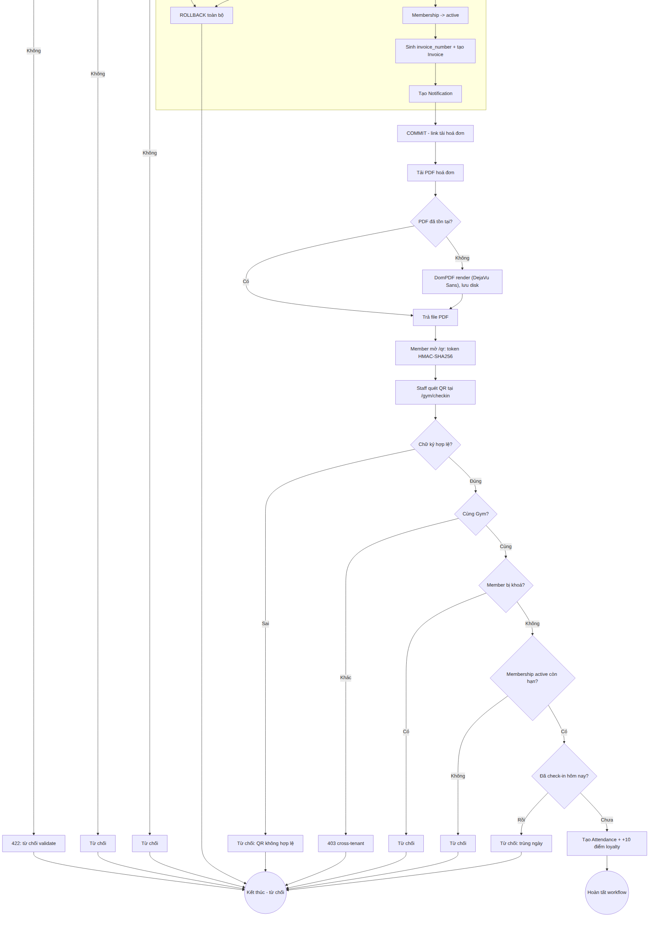
Figure 2b. Activity diagram, part 2: generate invoice, QR check-in (five validation checks)

3.3 Sequence Diagram
The sequence diagram shows the call order across the Member, Staff, Controller, Service, database, and PDF layers for the same core workflow. The two 'alt' blocks correspond to the two real atomic transactions in the code: payment confirmation and check-in.
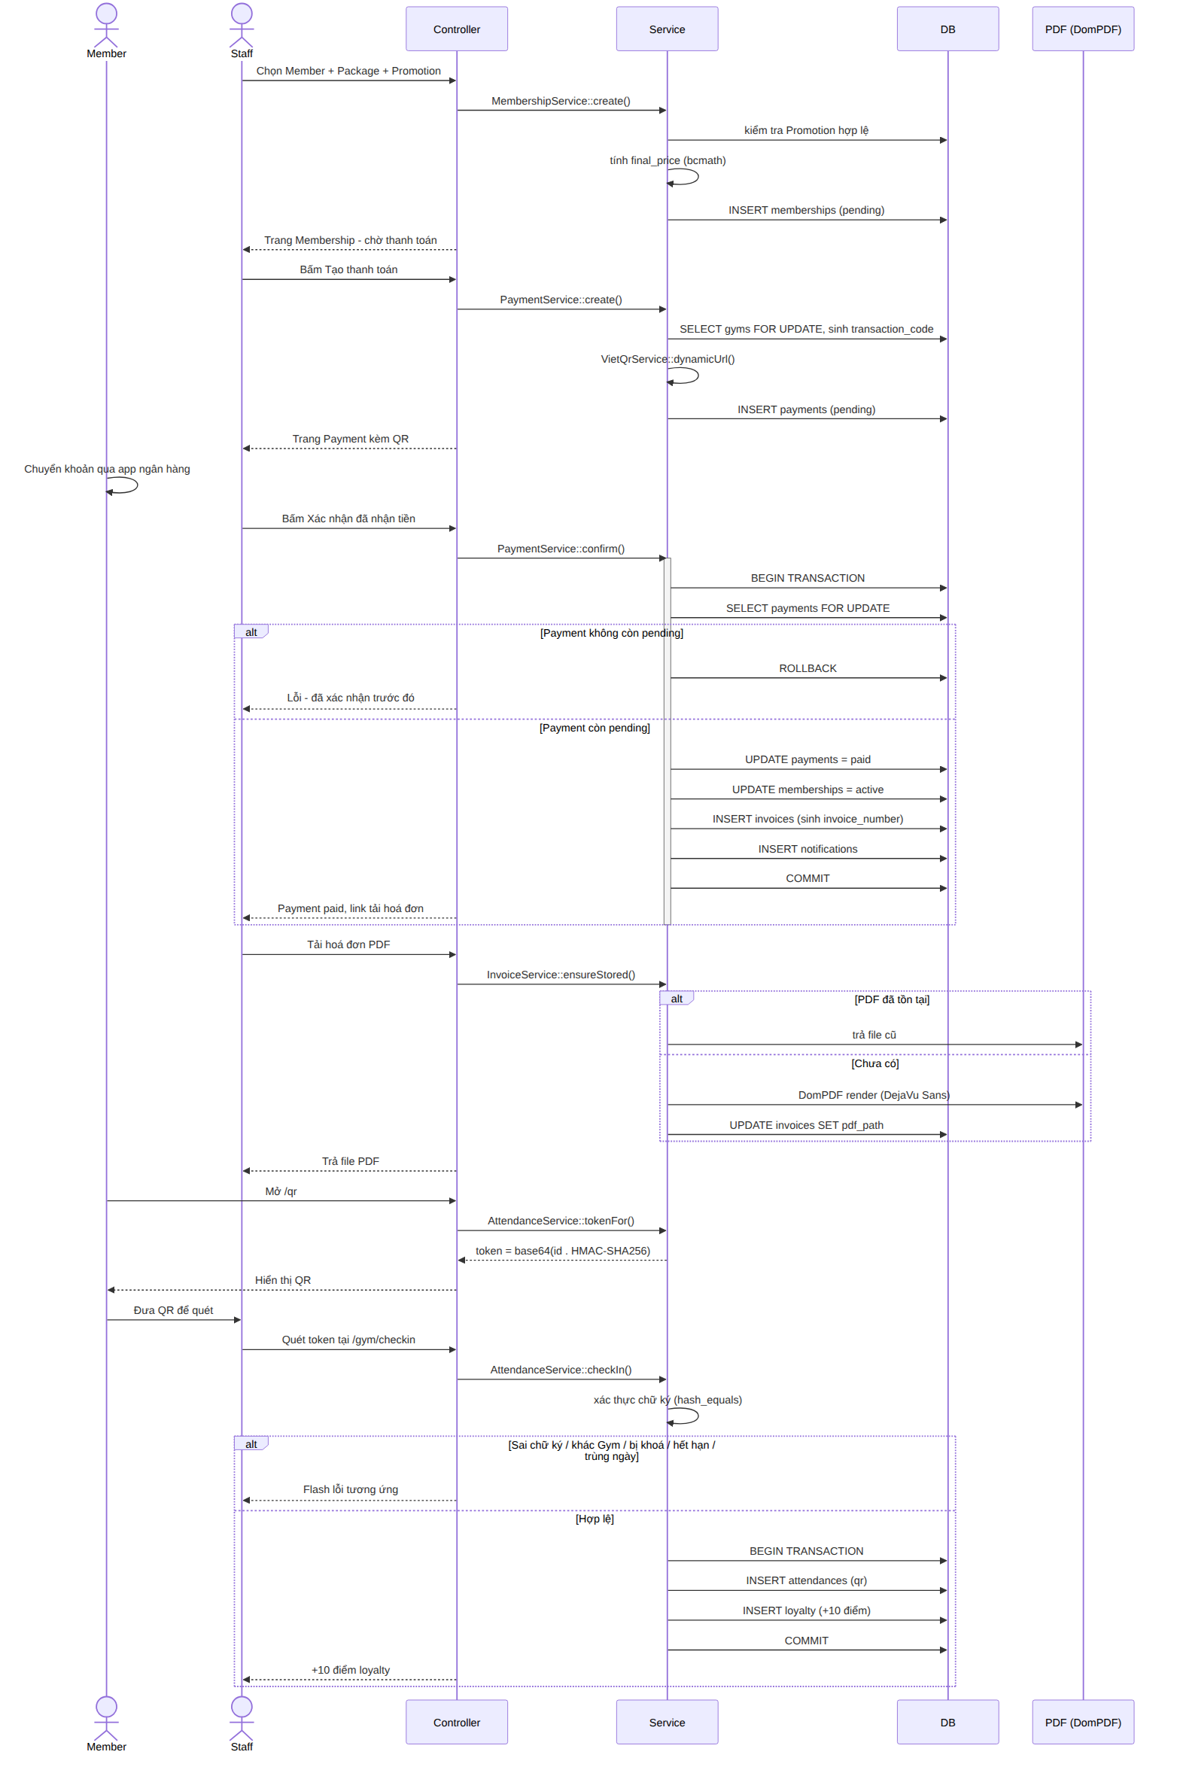
Figure 3. Sequence diagram: payment confirmation and QR check-in
3.4 Application Architecture
GymHub follows Laravel's layered architecture, extended with an explicit Service layer and Policy layer, chosen to keep the code easy to explain, review, and maintain.
Layer | Responsibility | Example in the project
Route + Middleware | Routes requests by role prefix, resolves the tenant, and blocks the wrong role with a 403 response. | EnsureTenantAccess, RoleMiddleware, route groups /admin, /gym, /staff, /trainer
Controller | A thin coordinator: receives the request, calls a Service, and returns a view. Contains no business logic. | MemberController, PaymentController, InvoiceController
Form Request | Validates input and calls the Policy before the Controller runs. | StoreMemberRequest, StoreMembershipRequest
Service | Holds all business logic and multi-step transactions. | MembershipService, PaymentService, InvoiceService, AttendanceService, ClassBookingService, EquipmentService
Policy | Backend authorisation, checking both role and gym_id (14 policies in total). | MemberPolicy, PaymentPolicy, SchedulePolicy
Model + Global Scope | Data access, automatically filtered by tenant. | BelongsToGym trait, applied to every business model
View (Blade) | The Vietnamese-language interface, built with Tailwind CSS and Alpine.js. | layouts/app and the module-specific views

3.5 Multi-Tenant Architecture
A tenant in GymHub is one gym. Every business table carries a gym_id column, and a shared trait called BelongsToGym attaches a global query scope to every business model. Whenever a logged-in user is not a platform admin, this scope silently adds a where gym_id = <the user's gym> condition to every query built on that model.
This has an important side effect. If a user tries to open a record that belongs to a different gym through a normal URL, the record is never found in the query in the first place, so the response is a 404, and this happens before any Policy class runs. Tenant isolation is therefore checked twice: the global scope is the first line of defence, and the Policy is the second, in case a query does not go through the model directly. The one deliberate exception in the whole codebase is the User model, which does not use the BelongsToGym trait, because Laravel's own authentication guard resolves User internally, and applying a tenant scope there creates infinite recursion. Instead, tenant separation for authentication-adjacent logic is enforced at the Member, Trainer, and Staff profile level, and by policies that check gym_id directly.

3.6 Technology Stack
Technology | Role in the project
Laravel 13 (PHP 8.4) | Main backend framework: routing, Eloquent ORM, authentication, validation, queues for scheduled jobs, and testing tools.
MySQL / SQLite | Primary relational database. MySQL is the configured production-style engine (via XAMPP); SQLite is used for the automated test suite and, after a local MySQL stability issue, for local development as well.
Blade | Laravel's server-side templating engine used for every view.
Tailwind CSS | Utility-first CSS framework used for the whole interface.
Alpine.js | Small JavaScript library used for lightweight interactive UI behaviour such as menus and toggles.
DomPDF | PHP library used to render Vietnamese-language PDF invoices.
VietQR quick-link image API | Used to generate the payment QR code image shown to members, based on the bank account, amount, and transfer content.
Composer / Node.js / npm | Dependency management for the PHP backend and the frontend build pipeline (Vite).
Git / GitHub | Version control, milestone tagging, and the v1.0 release.

4. Database Design

4.1 Database Overview
The database is the backbone of tenant isolation and of the whole business workflow. It is generated from 37 real migration files rather than designed on paper first and implemented later, so the schema described here is guaranteed to match what actually runs. Almost every business table carries a gym_id foreign key used for automatic tenant isolation; the only exceptions are three child tables (package_promotions, workout_plan_items, nutrition_plan_items), which are isolated indirectly through their parent table.

4.2 Database Schema (ERD)
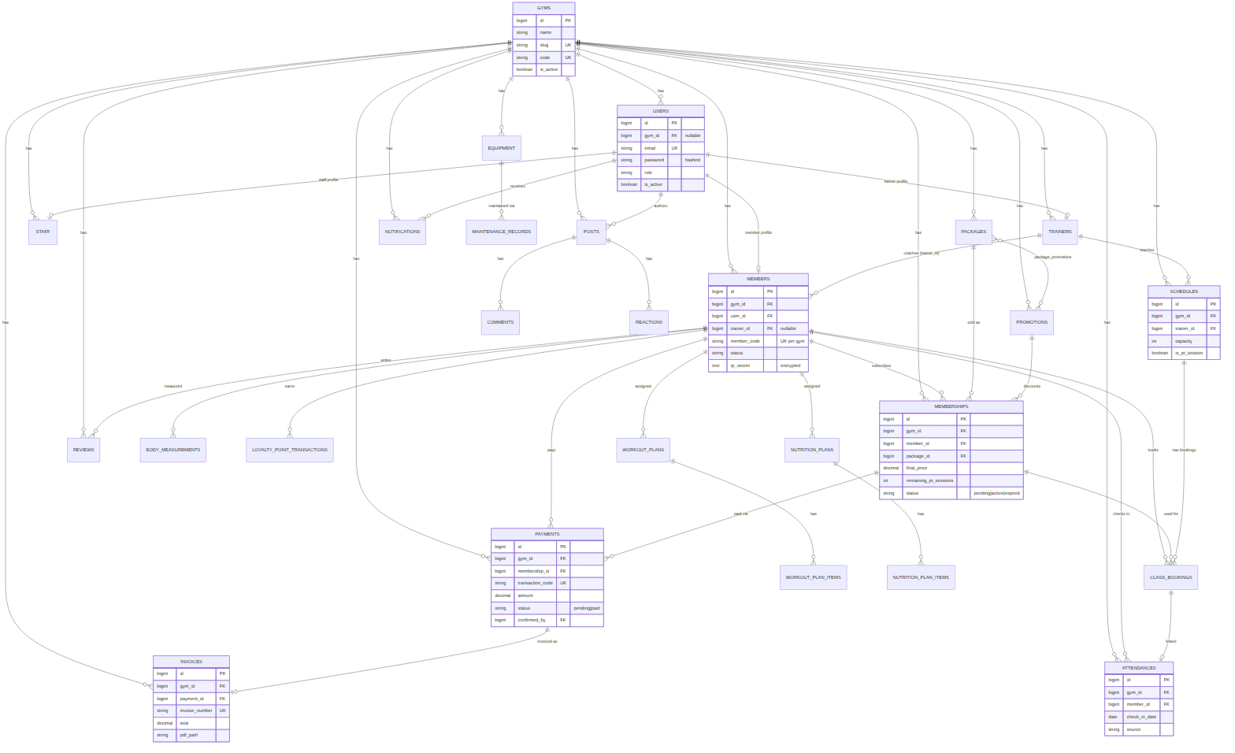
Figure 4. Entity-relationship diagram of the core business tables
The diagram above shows the core entities of the business workflow. The complete column-level detail for every table is given in the data dictionary in section 4.3.

4.3 Data Dictionary
The following convention applies to every table unless stated otherwise: each table has an auto-incrementing bigint primary key called id, together with created_at and updated_at timestamps. A deleted_at column is present only on tables marked 'soft delete: yes' below, and a gym_id column is a foreign key to the gyms table.

- gyms
Column | Type | Key / null | Description
name | string |  | Gym name
slug | string | unique | URL identifier
code | string(10) | unique, nullable | Short prefix (e.g. FZ) used to build member codes, transaction codes, and invoice numbers
address / phone / email | string | nullable | Contact details
opening_time / closing_time | time | nullable | Business hours
is_active | boolean | default true | Turned on or off by the platform admin

- users
Column | Type | Key / null | Description
gym_id | bigint | FK, nullable | Null for a platform admin
name | string |  | Full name
email | string | unique | Login identifier
password | string |  | Bcrypt hash (cast as 'hashed')
role | string |  | platform_admin, gym_owner, staff, trainer, or member
is_active | boolean | default true
last_login_at | timestamp | nullable

- members
Column | Type | Key / null | Description
gym_id | bigint | FK
user_id | bigint | FK, unique | One user maps to one member profile
trainer_id | bigint | FK, nullable | Main assigned trainer
member_code | string | unique per gym | e.g. FZ-0001, generated sequentially with row locking
status | string |  | active, expired, or blocked
height / weight | decimal(5,2) | nullable | cm / kg
qr_secret | text | nullable, encrypted | Per-member key used to sign the QR check-in token

- trainers.
Column | Type | Key / null | Description
gym_id / user_id | bigint | FK / FK, unique
specialization | string | nullable | Area of expertise
rating_avg | decimal(3,2) | default 0
is_active | boolean

- staff
Column | Type | Key / null | Description
gym_id / user_id | bigint | FK / FK, unique
position | string | nullable | Job title
is_active | boolean

- packages
Column | Type | Key / null | Description
gym_id | bigint | FK
name | string
price | decimal(12,2)
duration_days | int |  | Validity period in days
pt_sessions | int |  | Personal-training sessions included
is_active | boolean

- promotions
Column | Type | Key / null | Description
gym_id | bigint | FK
code | string | unique per gym
discount_type | string |  | percent or fixed
discount_value | decimal(12,2)
start_date / end_date | date |  | Validity window
usage_limit / used_count | int |  | Cap and current usage
is_active | boolean

- memberships
Column | Type | Key / null | Description
gym_id / member_id / package_id | bigint | FK
promotion_id | bigint | FK, nullable
start_date / end_date | date |  | end = start + duration_days
original_price / discount_amount / final_price | decimal(12,2) |  | Computed with bcmath; final price cannot go below zero
remaining_pt_sessions | int |  | Personal-training sessions left
status | string |  | pending, active, expired, or cancelled

- payments
Column | Type | Key / null | Description
gym_id / membership_id / member_id | bigint | FK
transaction_code | string | unique | PAY-{gym}-{date}-{sequence}
amount | decimal(12,2)
method | string |  | bank_transfer or cash
status | string |  | pending, paid, failed, or cancelled
qr_payload | string | nullable | VietQR image URL
paid_at | timestamp | nullable
confirmed_by | bigint | FK, nullable | Staff member who confirmed the payment

- invoices
Column | Type | Key / null | Description
gym_id / payment_id / member_id | bigint | FK
invoice_number | string | unique | INV-{gym}-{date}-{sequence}
subtotal / discount / total | decimal(12,2)
pdf_path | string | nullable | Generated on first request and reused afterwards

- schedules
Column | Type | Key / null | Description
gym_id | bigint | FK
trainer_id | bigint | FK, nullable
class_date | date
start_time / end_time | time
capacity | int
is_pt_session | boolean |  | True for a one-to-one PT session
status | string |  | scheduled, cancelled, or completed

- class_bookings
Column | Type | Key / null | Description
gym_id / schedule_id / member_id | bigint | FK
membership_id | bigint | FK, nullable | Used to refund the correct PT session on cancellation
status | string |  | booked or cancelled
booked_at / cancelled_at | timestamp | nullable

- attendances
Column | Type | Key / null | Description
gym_id / member_id | bigint | FK
trainer_id / class_booking_id | bigint | FK, nullable
check_in_date | date
check_in_time | timestamp
source | string |  | qr or manual

- body_measurements
Column | Type | Key / null | Description
gym_id / member_id | bigint | FK
recorded_by | bigint | FK, nullable
measured_at | date
height / weight / body_fat_percent / muscle_mass / bmi | decimal(5,2) | nullable | BMI computed as weight / (height/100)^2

- equipment
Column | Type | Key / null | Description
gym_id | bigint | FK
name / category | string
purchase_date | date | nullable
status | string |  | active, maintenance, or retired
maintenance_interval_days | int | nullable
last_maintenance_at / next_maintenance_at | date | nullable
A few additional tables complete the schema but are grouped here for brevity rather than shown in full: workout_plans / workout_plan_items and nutrition_plans / nutrition_plan_items (training and diet content written by a trainer for an assigned member), posts / comments / reactions (the community feed), reviews, notifications, and loyalty_point_transactions (an event-sourced ledger of loyalty points), plus maintenance_records for equipment history. Three additional tables, rewards, salaries, and audit_logs, exist at the schema level only and are covered in section 10 as future development. Laravel's own framework tables (sessions, cache, jobs, password_reset_tokens, and similar) are not part of the business data dictionary.

4.4 Main Relationships
- A gym has many members, trainers, staff, packages, promotions, schedules, equipment, and community posts.
- A member has one membership at a time in its current active cycle, and a full history of past memberships.
- A membership has one payment, and a paid payment produces exactly one invoice.
- A member has many attendance records, class bookings, body measurements, and reviews.
- A trainer is optionally assigned to many members, and separately assigned to many schedules as the class or PT instructor.
- A piece of equipment has many maintenance records over its lifetime.

5. Application Development and Implementation
This section walks through how each business module was actually implemented, module by module, and points to the service class and tests that back each claim.

5.1 Authentication and Authorisation
Login, registration, password reset, and email verification are built on Laravel's authentication scaffolding, customised so that registration requires choosing a gym and so that a disabled account or a deactivated gym cannot log in. After login, the user is redirected to the dashboard that matches their role. Authorisation then works in two layers: role middleware blocks the wrong role from reaching a whole route group (for example, only staff, owner, and platform-admin roles can reach /gym routes), and 14 Policy classes check finer-grained rules, such as whether the current staff member is even allowed to edit this particular member.

5.2 Member and Membership Management
Staff and owners manage members through a standard CRUD interface with search by name, email, member code, or phone, filtering by status and join-date range, sorting, and soft delete with recovery. Each member is given a sequential, human-readable code such as FZ-0001, generated safely under concurrent requests by combining a row-level lock (SELECT ... FOR UPDATE) with a retry loop if a unique-constraint collision still happens. Creating a membership picks a member, a package, and an optional promotion, and MembershipService computes the final price with bcmath so that percentage and fixed discounts never introduce floating-point rounding errors, and the final price is never allowed to go negative. A new membership is always created as pending; it is never activated at creation time.

5.3 Package and Promotion Management
Packages and promotions both have full CRUD screens. Each package stores a price, a validity period in days, and the number of personal-training sessions it includes. A promotion has a discount type (percentage or fixed amount), a validity window, and a usage limit; it can only be attached to a package while its start and end dates are still valid, so an expired promotion code is rejected automatically rather than relying on staff to notice the date.

5.4 Payment and Invoice Workflow
This is the workflow at the centre of the project. A staff member creates a payment for a pending membership, and PaymentService generates a unique transaction code plus a VietQR image URL that already encodes the exact amount and the transfer content the member should use. The member (or staff, on the member's behalf) transfers the money through their own banking app, and staff then compare the real bank statement against the transaction code before pressing confirm.
Confirmation is where the atomicity requirement matters most. PaymentService::confirm() wraps four writes in a single DB::transaction(): the payment status becomes paid, the related membership becomes active, an Invoice record is created, and a Notification is created for the member. If any one of these four steps throws an exception, for example because invoice generation fails, the whole transaction is rolled back and none of the four changes are kept, so the system never charges a member without activating their package. A guard also stops the same payment from being confirmed a second time, which would otherwise create a duplicate invoice. This behaviour is proven, not just claimed: PaymentConfirmationTest includes a test that mocks a mid-transaction exception and then asserts that zero records changed.
The invoice itself is rendered as a one-page Vietnamese-language PDF using DomPDF with the DejaVu Sans font, which is needed because Vietnamese diacritics do not render correctly with DomPDF's default fonts. The PDF is generated once and reused on later downloads rather than being rebuilt every time. During testing, the invoice header originally used a CSS float layout, which caused DomPDF to break the header text into single characters and push content onto a second page. The fix was to rebuild the header with an HTML table instead of floats, since DomPDF is documented to handle table layouts more reliably than CSS floats and clears; this is one of the concrete bugs discussed again in section 8.6.

5.5 QR Check-in
Every member has a QR token built from their own member ID and an HMAC-SHA256 signature computed with a secret key stored only for that member (encrypted at rest, generated the first time the member's QR page is opened). The system deliberately avoids putting a raw member ID directly into the token, because that would let someone guess or enumerate valid IDs; instead, the signature is what is actually checked. Verification uses hash_equals for a timing-safe comparison, which avoids leaking information through response-time differences. A scan is rejected if the signature does not match, if the member's membership has expired, if the member's account is blocked, if the member belongs to a different gym than the scanning staff member, or if the member has already checked in that day. A valid check-in also adds ten loyalty points to the member's balance.

5.6 Schedule and Class Booking
Schedules cover both group classes (yoga, boxing, general strength classes, and similar) and one-to-one personal training sessions, each with a date, a time range, a capacity, and an assigned trainer. ClassBookingService enforces several rules at once when a member books a class: the class must not be full, the member must not already have another booking that overlaps the same time slot, the member's membership must be active, and, for a PT session, the member must still have PT sessions remaining on their package, which are deducted on booking and correctly refunded on cancellation.

5.7 Trainer Tools and Member Progress
A trainer's dashboard shows their own teaching schedule and only the members who have actually been assigned to them, using the trainer_id stored on each member's profile. From there, a trainer can log a body measurement (height, weight, body fat percentage, and muscle mass), with BMI computed automatically, and can build a workout or nutrition plan with individual exercises or meals. All of these actions are checked by a Policy that confirms the member is really assigned to the acting trainer; acting on an unassigned member of the same gym returns 403, and acting on a member from a different gym returns 404.

5.8 Community
Each gym has its own feed of posts, comments, and emoji-style reactions, entirely separate from other gyms' feeds. Posts can be marked as a plain post, an announcement, an event, or a challenge, and an announcement can be pinned to the top of the feed. Staff and owners can moderate content that breaks the gym's rules.

5.9 Notifications and Reviews
A notification bell in the top bar shows read and unread notifications for events such as a confirmed payment, a new class booking, or a membership close to expiry. Reviews let a member rate either the gym itself or a specific trainer from one to five stars with an optional comment; reviews can be hidden through moderation, and a trainer only ever sees the reviews written about themselves, never about colleagues.

5.10 Equipment and Maintenance
Equipment records store a category, purchase date, current status (active, under maintenance, or retired), a maintenance interval in days, and the last and next maintenance dates. The dashboard highlights equipment approaching its next maintenance date so staff do not have to check every item manually. Recording a maintenance event originally updated the maintenance record and the equipment's maintenance dates as two separate writes; a security review found that these two writes were not wrapped in a transaction, so a failure between them could leave inconsistent dates. This was fixed by wrapping the operation in DB::transaction(), and is discussed again as a real bug in section 8.6.

5.11 Dashboards and Reports
Each of the five roles has a dashboard built from live database numbers: total and active members, pending payments, memberships close to expiry, today's check-ins, upcoming classes, and equipment due for maintenance, depending on the role. Owners additionally have a monthly revenue report broken down by package, computed strictly within their own gym; DashboardReportsTest confirms directly that the owner of one gym never sees the revenue figures of another gym, even when that other gym has higher revenue.

6. UI/UX Design

6.1 Design Approach
The interface follows a common SaaS dashboard pattern: a left sidebar for navigation and a top bar with a notification bell and the current user's name and role. Each of the five roles sees a sidebar built only from the menu items that role is allowed to use, so navigation itself communicates what a role can and cannot do, in addition to the backend checks described in section 7. The layout is built mobile-first with Tailwind CSS so that the same pages remain usable on a phone, a tablet, and a desktop screen without a separate mobile version. The whole interface is written in Vietnamese, matching the target users.
Early in development, some menu items were missing for certain roles even though the underlying route and controller already existed, which meant a feature was implemented but not reachable from the interface. This was corrected during the project by auditing each role's sidebar against the actual route list and adding the missing links, so that, by the final version, every implemented function can be reached directly from the navigation for the role that is allowed to use it.

6.2 Member and Trainer Interface
A member's dashboard opens on their current package, days remaining, recent payments, and recent check-ins placed close together, since these are the numbers a member checks most often. From there, a member can view their QR check-in code, book or cancel a class, browse the community feed, and follow their own body-measurement history and training plans. A trainer's interface is built around the same idea from the coaching side: today's teaching schedule and the list of assigned members are the first things shown after login.

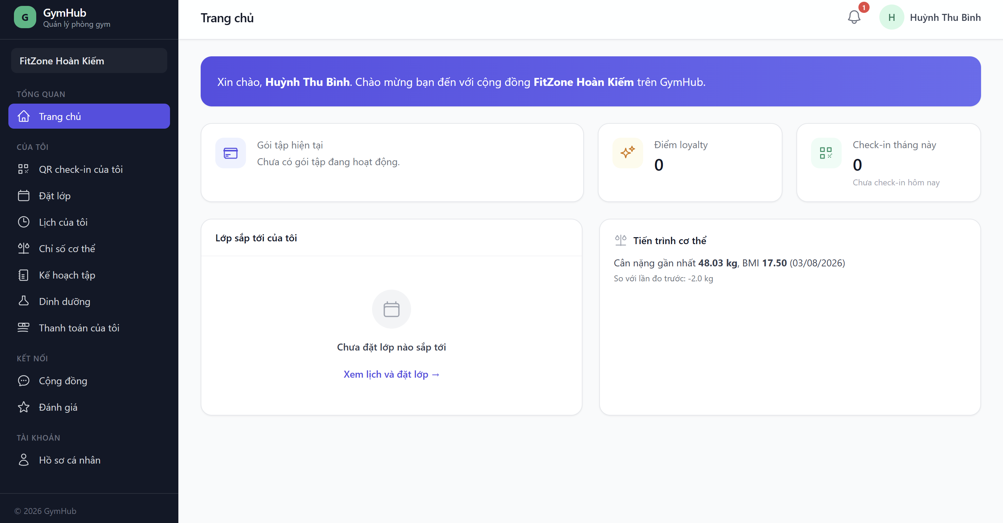

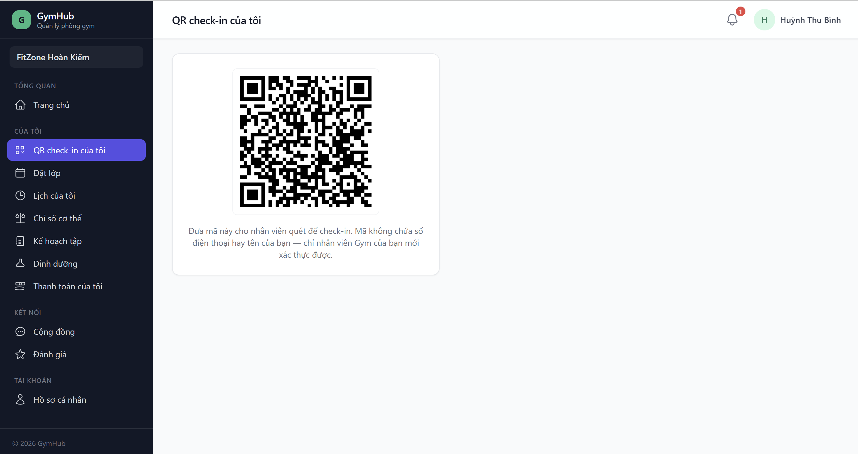

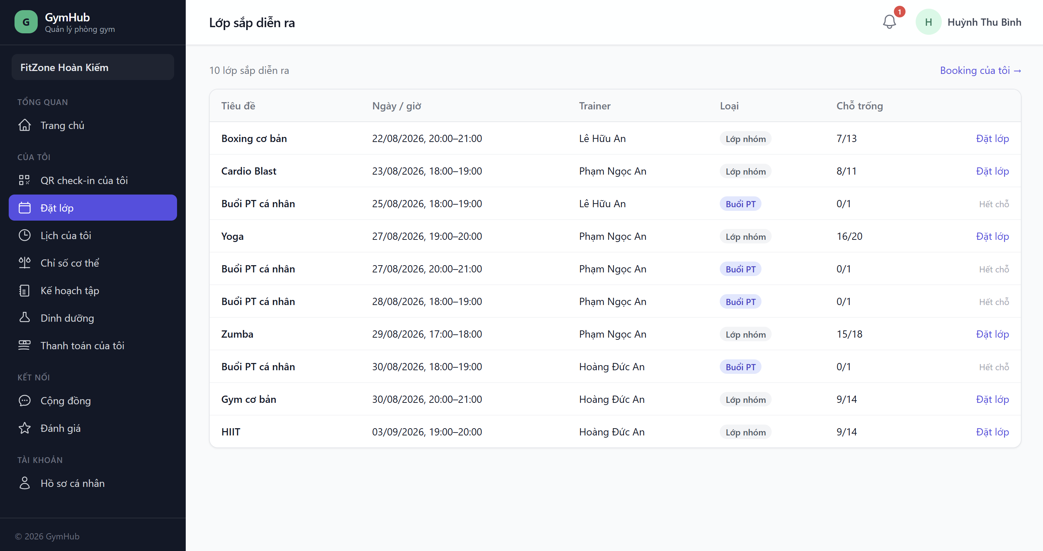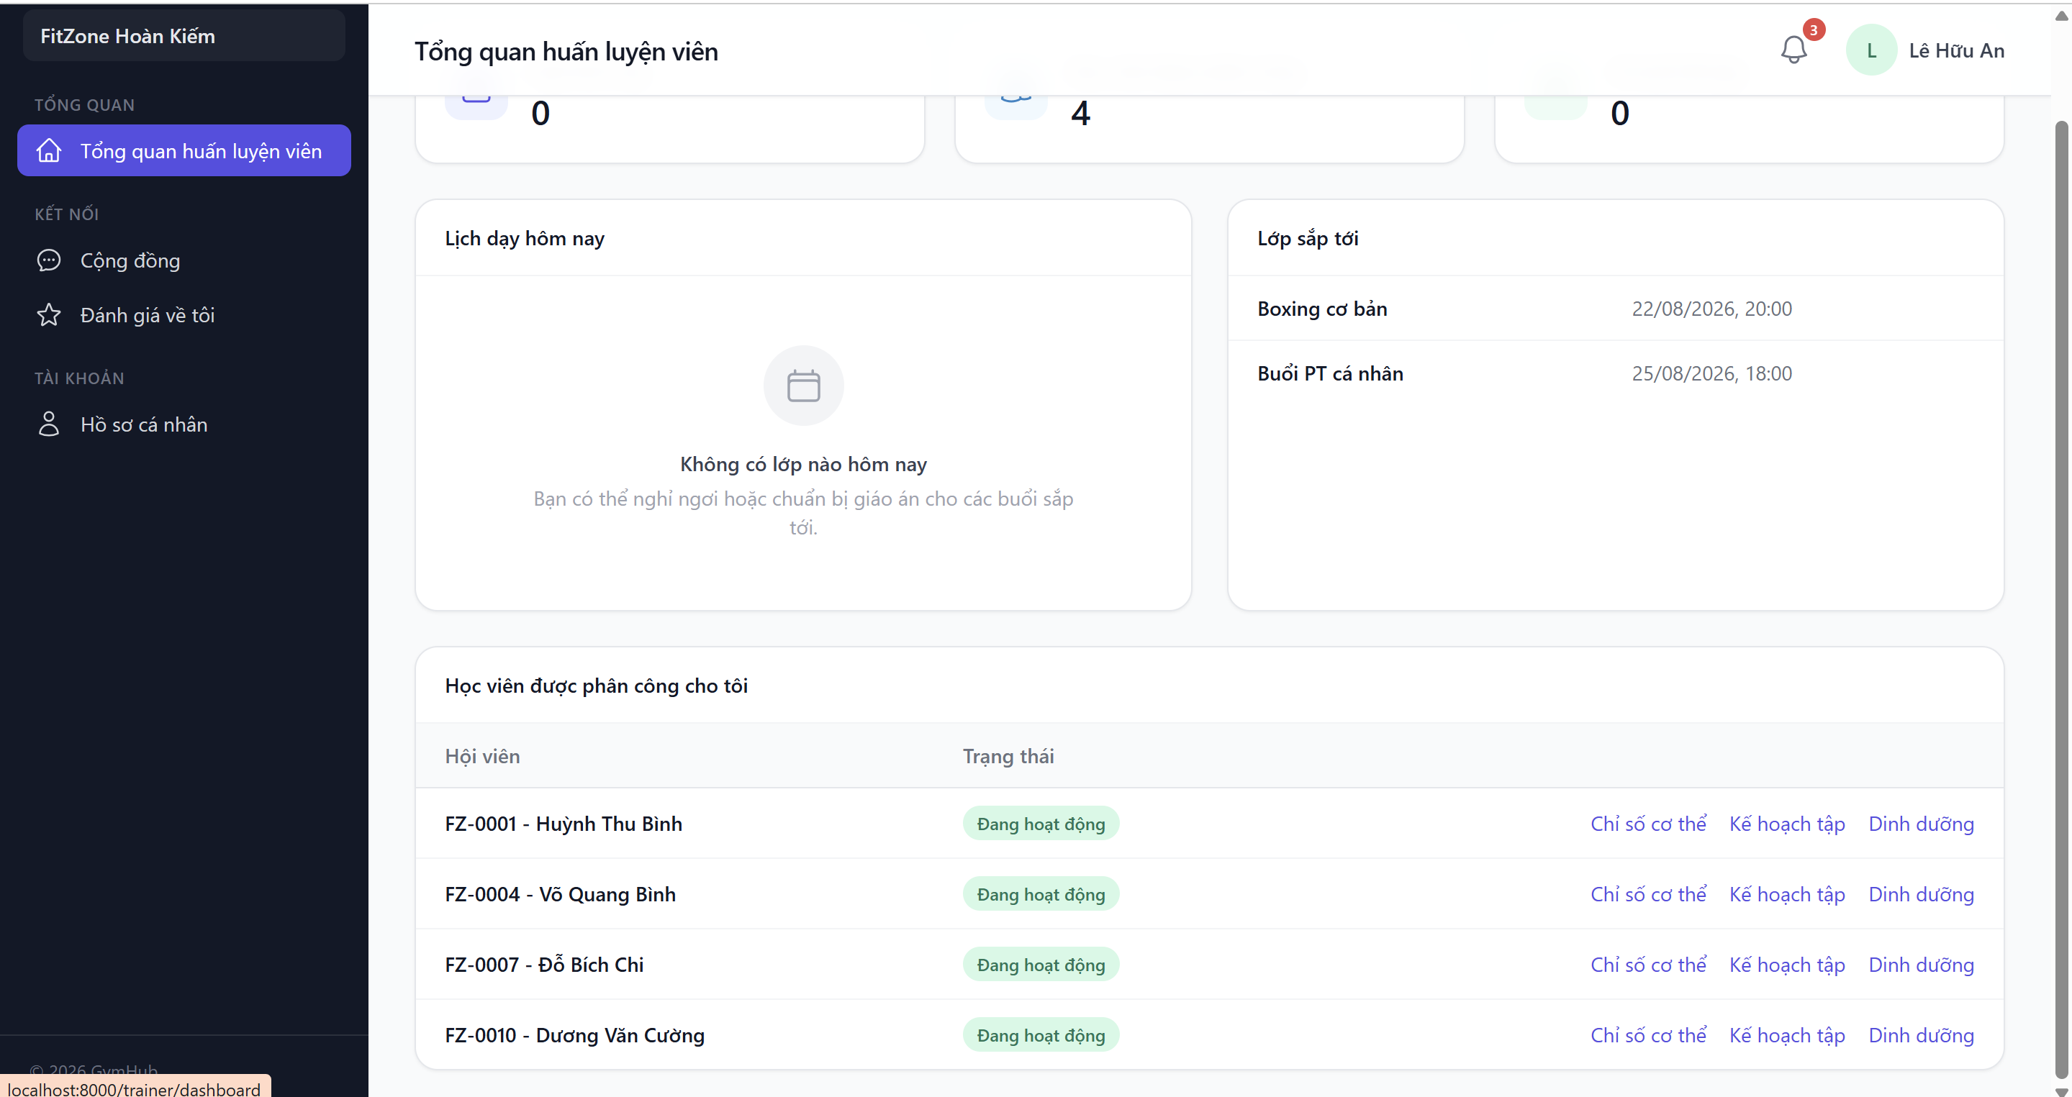

6.3 Administrator and Manager Interface
The platform admin interface is intentionally simple: a list of every gym with its status, and a single action to activate or deactivate a gym, plus a combined overview of platform-wide numbers. The gym owner interface is the richest in the system, covering members, packages, promotions, memberships, payments, invoices, schedules, equipment, community moderation, and the revenue report. The staff interface reuses the same components as the owner's for day-to-day operations such as member management and payment confirmation, but does not expose the financial report screens, matching the role's intended scope described in section 1.5.

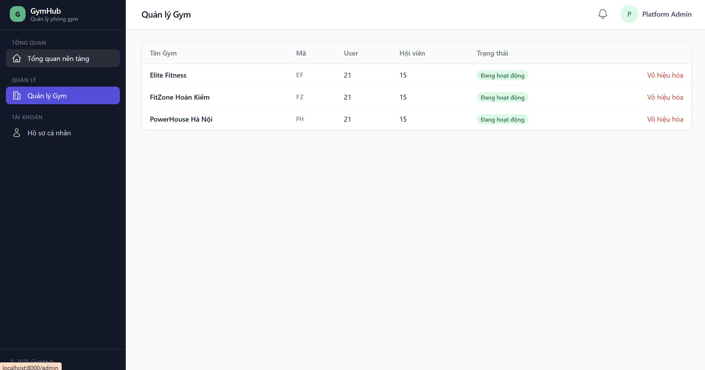

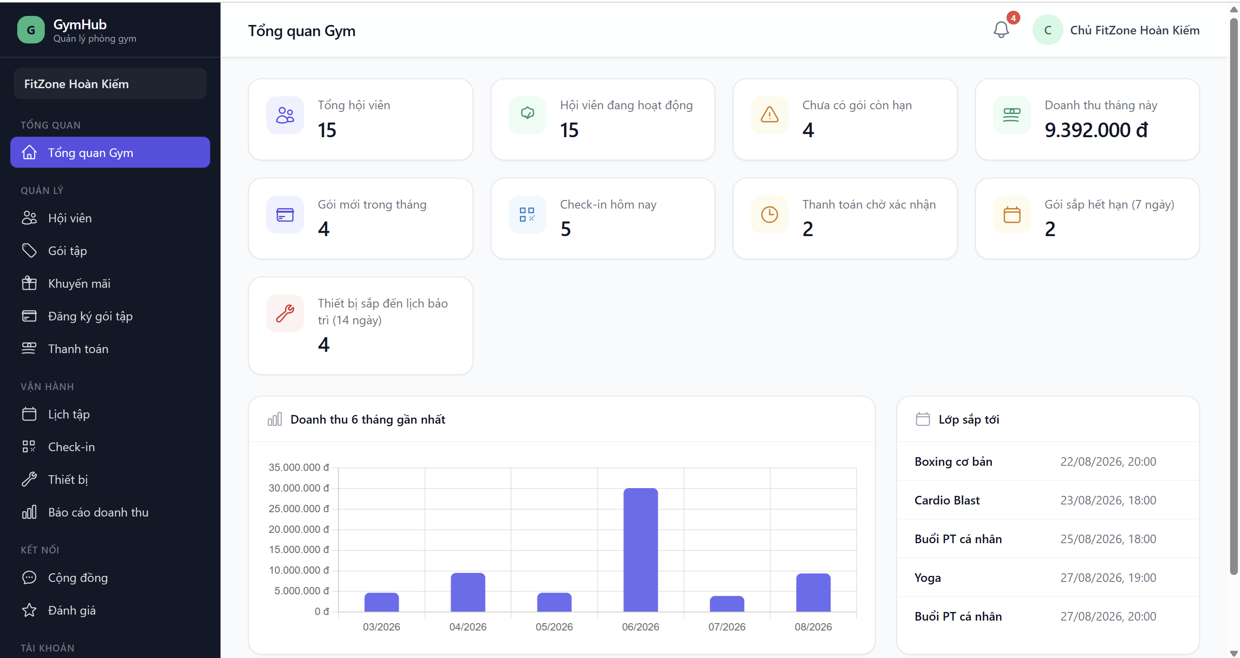

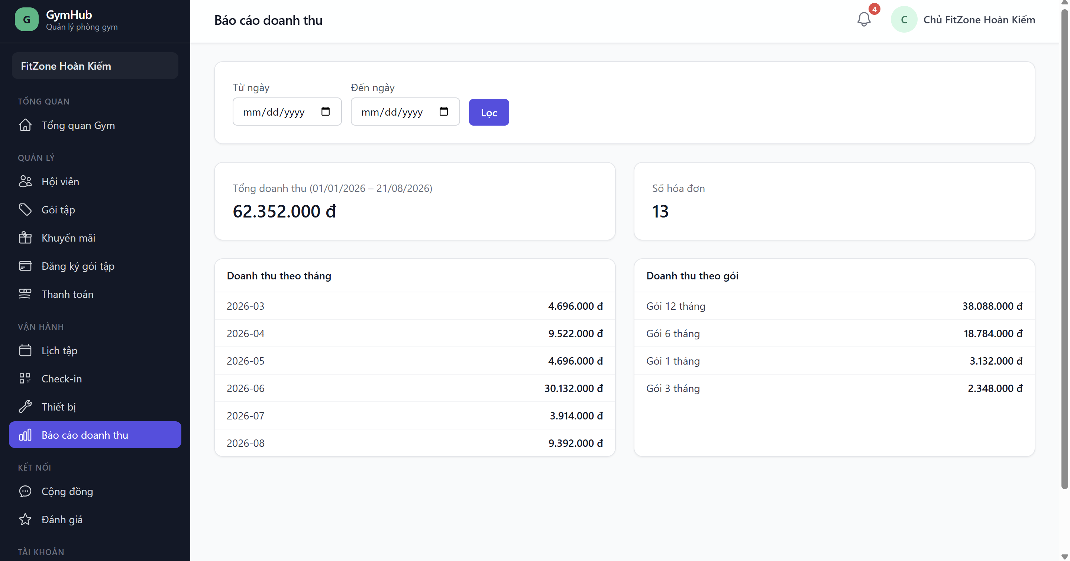

6.4 Validation, Notifications, and Error Messages
Form input is validated through Laravel Form Request classes before it reaches a controller, and validation errors are shown next to the relevant field in Vietnamese. Actions that succeed or fail, such as confirming a payment or booking a class, show a flash message immediately after the redirect. Blocked actions, for example trying to open a resource from another gym, return a proper 403 or 404 HTTP response rather than a broken page, and the notification bell described in section 5.9 gives members an ongoing view of events relevant to them.

7. Security and Data Protection
The table below lists the concrete security controls implemented in GymHub, matched against the course's security checklist, with the mechanism and its rough location in the codebase.
Control | Mechanism and location
Password hashing | The password attribute on the User model is cast as 'hashed', so Laravel bcrypt-hashes it automatically; Hash::make() is used again whenever a password is changed.
CSRF protection | Laravel's default web middleware group plus an @csrf token on every POST, PUT, and DELETE form.
XSS protection | All Blade output uses the auto-escaping {{ }} syntax. The one place using raw {!! !!} output is the SVG QR code image, which is generated entirely by the server, not from user input.
SQL injection protection | All queries go through Eloquent or the query builder with parameter binding; there is no raw query built by concatenating user input.
Backend authorisation | 14 Policy classes plus Form Request authorize() methods; platform-only and dashboard routes are locked by role middleware, not only hidden in the menu.
Tenant isolation | The BelongsToGym global scope (returns 404 at the query/route-binding level), Policy checks on gym_id, and Rule::exists()->where('gym_id', ...) validation rules in Form Requests.
Database transactions | Six Service classes use DB::transaction() for multi-step business writes: membership creation, payment confirmation, booking, attendance, and equipment maintenance.
Soft deletes | Applied to nine important tables, including members, trainers, staff, packages, memberships, schedules, posts, and equipment, so accidental or moderated deletion is recoverable.
Secret management | .env is listed in .gitignore and was never committed; only .env.example is tracked, with empty or placeholder values, so no real credential or bank account number is exposed in the repository.
The strongest single piece of evidence for tenant isolation is TenantIsolationTest, which logs in as the owner of gym A and then tries to reach every type of resource belonging to gym B (members, payments, invoices, schedules, posts, reviews, and equipment) through GET, PUT, POST, and DELETE requests. Every one of these attempts returns 403 or 404, and no record is changed or deleted as a result.
Input validation is centralised in Form Request classes rather than scattered across controllers, which makes it possible to see every validation rule for a given action in one file, and every Form Request also calls its Policy's authorize() method before the controller runs, so validation and authorisation happen at the same point in the request lifecycle.

8. Testing and Results

8.1 Test Strategy
Testing was written alongside each feature rather than added at the end, using Laravel's feature and unit test tooling built on PHPUnit. Each test class targets one business module, with valid, invalid, and boundary cases, plus a dedicated cross-tenant case wherever the module touches gym-scoped data. The security-focused TenantIsolationTest was written as a separate pass across every resource type, on top of the isolation checks already built into each module's own test class.

8.2 Test Environment
The whole suite runs against SQLite, using Laravel's RefreshDatabase trait so that every single test starts from a clean, migrated schema and cannot be affected by data left behind by another test. This keeps the suite fast enough to run in full after almost every change, and is one of the reasons a genuine driver-specific bug (described in section 8.6) was caught early rather than only appearing later in a MySQL environment.

8.3 Test Cases and Results
The final result of the suite is 214 out of 214 tests passing, with 588 assertions and zero failures. The table below lists the main test classes and what each one is responsible for proving.
Test class | Tests | Purpose
TenantScopeTest | 5 | Confirms the global scope: a gym A user only ever sees gym A data, a platform admin sees everything, and CLI/seeder context is not filtered.
Auth/* (6 classes) | 23 | Login, logout, registration with mandatory gym selection, email verification, password reset/change, and blocking a disabled account or gym.
RoleAccessTest | 7 | Role middleware returns 403 for the wrong role; cross-tenant access returns 404; users land on the correct dashboard.
MemberManagementTest | 8 | Sequential, non-duplicate member codes; search/filter; soft delete and recovery; cross-tenant 404.
MembershipCreationTest | 11 | Percentage and fixed discount calculation; membership always starts pending; an expired promotion is rejected; cross-tenant creation is blocked.
PaymentCreationTest | 8 | Payment created as pending; sequential and unique transaction codes; view permissions; cross-tenant 404.
PaymentConfirmationTest | 7 | Atomic confirmation (paid + active + invoice + notification); a mocked mid-transaction failure rolls back completely; a payment cannot be confirmed twice.
InvoiceDownloadTest | 6 | The PDF is a real file larger than 0 bytes, is reused rather than regenerated, and download access is correctly restricted.
ScheduleManagementTest | 6 | Schedule CRUD, blocking a capacity reduction below the number already booked, cross-tenant checks.
ClassBookingTest | 20 | Membership, capacity, and time-overlap rules; correct PT-session deduction and refund; cancellation; cross-tenant checks; a regression test for a membership starting exactly today.
AttendanceCheckInTest | 13 | HMAC-signed tokens, forgery rejection, blocking expired/blocked/duplicate-day/cross-tenant check-in, and the +10 loyalty point award.
TrainerAssignmentTest | 12 | A trainer can only act on assigned members (403 for an unassigned member of the same gym, 404 across gyms).
BodyMeasurementTest / WorkoutNutritionPlanTest | 9 | Correct BMI calculation, and trainer/member permission checks when recording measurements and building plans.
CoreWorkflowEndToEndTest | 1 | The strongest demonstration test: the whole workflow, from choosing a package to checking in, executed through the real services with no mocking.
CommunityFeedTest | 19 | Feed scoped by gym, posting and moderation permissions, reaction toggling, pinning, cross-tenant checks.
NotificationTest / ReviewTest | 20 | Notifications scoped by user and gym across four triggers; 1-5 star reviews, moderation, and trainers seeing only their own reviews.
DashboardReportsTest | 13 | Correct numbers per role; gym A revenue never appears for gym B; gym activation/deactivation.
EquipmentTest | 10 | CRUD scoped by gym, maintenance recording updates the schedule correctly, warning counts, cross-tenant checks.
TenantIsolationTest | 7 | The combined security proof: the owner of gym A is rejected with 403/404 on every type of gym B resource.

8.4 Security and Tenant Isolation Tests
Tenant isolation is not treated as a side effect of normal feature tests; it has its own dedicated test class, TenantIsolationTest, described in section 7, and it is reinforced by cross-tenant assertions inside almost every other feature test class listed above. This double coverage was a deliberate choice, since tenant isolation is the single most important non-functional requirement of a multi-tenant SaaS product.

8.5 Problems Found During Testing
Two real defects were found and fixed during development, and both are kept here for transparency instead of being written out of the final report.

Date comparison bug in class booking and attendance
ClassBookingService and AttendanceService originally compared a membership's start_date using a plain where() clause instead of Laravel's whereDate() helper. On SQLite, this caused a membership that started on exactly the current day to be wrongly rejected, because the raw string comparison did not line up with how SQLite stores date values. The bug was found through an end-to-end test rather than a unit test, was fixed in both services, and a regression test was added to ClassBookingTest and AttendanceCheckInTest so it cannot silently come back.

Missing transaction in equipment maintenance
EquipmentService::recordMaintenance() originally performed two writes, creating a maintenance record and updating the equipment's maintenance dates, without wrapping them in a transaction. This was found not by a failing test but during a manual security checklist review, and was fixed by wrapping the method body in DB::transaction(), matching the pattern already used everywhere else multi-step writes happen.

8.6 Unresolved Defects
No unresolved defect is currently tracked against the 214 passing tests. [TO BE COMPLETED: if any issue is found during final rehearsal or live demonstration before submission, describe it honestly here rather than omitting it, since the course explicitly allows and expects unresolved defects to be disclosed if they exist.]

9. Installation, Deployment and Project Management

9.1 Installation Guide
The application targets Windows with XAMPP (Apache and MySQL), PHP 8.4, Composer, Node.js, and Git. The steps below are the exact commands used during development.
Clone the repository and install dependencies:
composer install
npm install
Create the environment file and application key:
Copy-Item .env.example .env
php artisan key:generate
Configure .env with DB_DATABASE=gymhub, DB_USERNAME=root, and an empty DB_PASSWORD, matching the default XAMPP setup. Start MySQL inside XAMPP and create a database called 'gymhub'.
Run migrations and seed the demo data:
php artisan migrate:fresh --seed
Build the frontend assets and start the server:
npm run build
php artisan serve
Open http://localhost:8000 in a browser and log in with one of the demo accounts below.

9.2 Test Accounts
All demo accounts share the password 'password'.
Role | Sample login
Platform Admin | admin@gymhub.test
Gym Owner | owner@fitzone.test, owner@powerhouse.test, owner@elite.test
Staff (2 per gym) | staff1@fitzone.test, and so on for each gym
Trainer (3 per gym) | trainer1@fitzone.test, and so on for each gym
Member (15 per gym) | member1@fitzone.test, and so on for each gym
The full suite can be run with php artisan test, or a single class can be targeted with, for example, php artisan test --filter=TenantIsolationTest.

9.3 GitHub Repository
Source code: https://github.com/met23080025-ui/Group4
The repository follows the Conventional Commits format, and commit history is spread naturally across the three development blocks rather than uploaded in one bulk commit at the end. The .env file was never committed; .env.example lists every required variable with empty or placeholder values. Design and analysis documentation lives in the /docs folder, written in Mermaid so diagrams render directly on GitHub without any extra tooling.

9.4 Project Management and Git History
Development was organised into three milestones, each closed with its own git tag and pushed to GitHub as visible, incremental progress rather than a single final upload.
Tag | Content
block1-foundation | Multi-tenant architecture, migrations, models with the global scope, seeders, authentication, role and policy middleware, and CRUD for members, packages, promotions, and memberships.
block2-core-workflow | VietQR payment, atomic confirmation, Vietnamese PDF invoices, schedules and class booking, QR check-in and attendance, trainers and body measurements, workout and nutrition plans.
block3-final | Community, notifications, reviews, role-based dashboards, revenue reports, equipment and maintenance, a security review pass, and full documentation.
A v1.0 release was created on GitHub once block3-final was complete and the full test suite passed.

10. Recommendations and Future Development
After the first version was finished, tested, and pushed to GitHub, the team continued refining GymHub in two directions: improving the existing user experience, and sketching realistic new business features. This section keeps a clear line between what is already implemented, described throughout sections 1 to 9, and what is designed or only proposed.

10.1 Already Implemented
Everything described in sections 1 through 9 of this report, including the full core workflow, the five role-based interfaces, and the 214 automated tests, is implemented and can be demonstrated directly from the running application.

10.2 Interface Improvements in Progress
Standardising the visual design system (colour palette, spacing, and typography) across the whole interface to a consistent modern SaaS look, including an active-item state in the sidebar and a notification bell and user menu in the top bar.
Completing the navigation menu for every role so that every implemented function is reachable directly from the interface, which was already partly done by auditing each role's sidebar against the real route list.
Making dashboards easier to read at a glance with icon-based statistic cards, colour-coded categories, and status labels for states such as pending, active, expired, and blocked.
Bringing the most important information on a member's profile closer together: current package, days remaining, payment history, and check-in history.

10.3 Deepening Existing Business Flows
Restating the main flows explicitly as input, condition checks, processing, and result, with additional valid, invalid, and boundary test cases added for each.
Making business state more visible in the interface, such as a payment waiting for confirmation, or a PT session marked as pending, completed, cancelled, or no-show.
Giving staff an immediate view of a member's package status right at check-in, and giving a trainer their teaching schedule for the day immediately after login.

10.4 Proposed New Features
The features below are proposed extensions to deepen the business scope of GymHub. None of them is implemented yet; each would follow the same tenant-isolation principle already used throughout the project (every record tagged with gym_id) and would ship with its own tests, the same way every existing module does.
Proposed feature | Business description
Member shop | Members buy training-related products, such as drinks, accessories, or supplements, through a product catalogue, a cart/order flow, and a purchase history.
Inventory management | Owners and staff track product stock, record stock in and out, and get low-stock warnings; linked to the shop so a sale automatically reduces stock.
Daily meal plans | Trainers design a detailed nutrition plan for each day of the week for their assigned members, and members can view their own day-by-day plan.
Equipment maintenance calendar | An upgrade of equipment management into a visual maintenance calendar (upcoming, overdue, completed), with clearer warnings on the owner and staff dashboard.
Member promotions and announcements page | A dedicated page where members can see the gym's current and upcoming promotions together with announcements and events.

10.5 Outside the Scope of This Version
In the interest of accuracy, three modules already have their database tables designed for schema consistency but do not yet have a working interface: loyalty point redemption for rewards (rewards, reward_redemptions), staff salary management (salaries), and an automatic audit log (audit_logs). These remain future development rather than finished features, and are not demonstrated or claimed as implemented anywhere else in this report.

11. Project Reflection
Building GymHub inside three tight development blocks taught the team more about trade-offs than about any single technology. The hardest design decision was not any one feature but keeping tenant data separated correctly everywhere. It is not enough to check a user's role; almost every query also has to check the gym ID, and it took real discipline to remember this on every new controller and service, not just the obvious ones like the member list.
One decision we are still glad we made was excluding the User model from the automatic tenant scope. It looked inconsistent at first, since every other model uses it, but applying the scope to User caused an infinite loop the moment Laravel's own authentication guard tried to look up the logged-in user, because that lookup itself triggered the scope, which needed the logged-in user, and so on. Understanding why this happened, rather than just working around the symptom, changed how carefully we thought about where a global scope is safe to use.
Testing surfaced two bugs we would not have caught by only reading the code. A date comparison written with a plain where() instead of whereDate() passed on our own machines for weeks, and only broke on SQLite when a membership happened to start on exactly the current day, which is exactly the kind of boundary case that is easy to skip when writing tests by hand. Finding it through an automated end-to-end test, rather than during a live demo, was the moment the value of the test suite became obvious to the whole team, not just to whoever wrote the tests.
Working with a local XAMPP MySQL installation was harder than expected. MySQL crashed twice during development, once recoverable by clearing corrupted InnoDB log files and once not recoverable in the time we had. Moving local development to SQLite, the same database our automated tests already used, turned an infrastructure problem into a non-issue, and it also proved a point we had only assumed before: that keeping the code database-agnostic through Laravel's migrations was worth the small extra care it took.
Git and GitHub were more work to keep disciplined than we expected for a three-day project. It was tempting to run git push without first checking that everything was actually committed, and we caught ourselves believing work was saved when it was not, more than once. Splitting the work into three tagged blocks with a clear stop-and-review point after each one is what kept the history honest and gave us something real to show as progress, instead of one large commit at the very end.
If we did this again, we would write the cross-tenant test for a module at the same time as its first feature test, instead of adding it afterwards, and we would decide the database schema for the three future-development modules a little earlier, so the report and the roadmap in section 10 would have been ready sooner instead of being written under time pressure near the end.

12. Conclusion
GymHub set out to answer a real problem: small and medium gyms managing members, payments, and equipment by hand, with no realistic option to share one system safely across several locations. The project delivers a working multi-tenant SaaS platform where each gym's data is isolated by the database's own global query scope and reinforced by backend policies, not only by interface design.
The core business workflow, from creating a membership to confirming a VietQR payment to issuing an invoice to checking in by QR code, is implemented as atomic, tested operations rather than a sequence of independent steps that could leave the system in an inconsistent state. Together with scheduling, trainer tools, a community feed, and role-based dashboards, this workflow is backed by 214 automated tests, all passing, including a dedicated suite proving that tenant isolation actually holds under direct attack, not only under normal use.
The current version has clear limitations, mainly manual payment reconciliation and three modules that exist only at the database level. These are stated plainly in this report rather than hidden, together with a concrete, realistic roadmap for what should come next. Overall, GymHub shows that a small student team, working inside a genuinely short schedule, can still produce a secure, tested, and honestly documented business application.

13. References
This project is a software development exercise rather than a research paper, so the references below are the official technical documentation the team consulted while building GymHub, rather than academic literature.
- Laravel 13 official documentation, https://laravel.com/docs
- PHP 8.4 manual, https://www.php.net/manual/en/
- Tailwind CSS documentation, https://tailwindcss.com/docs
- Alpine.js documentation, https://alpinejs.dev/
- DomPDF documentation, https://github.com/dompdf/dompdf
- VietQR quick-link image API documentation, https://vietqr.io/
- Git documentation, https://git-scm.com/doc

14. AI and Tool-Use Declaration
An AI coding assistant (Claude, by Anthropic, used through a command-line tool) supported development across all three blocks of the project. The team remains responsible for the correctness, security, and originality of the submitted work, and can explain and modify every part of it during the demonstration.
AI / tool | Purpose of use | Main parts assisted | How the output was verified
Claude (Anthropic), via a command-line coding assistant | Requirements analysis support; proposing and helping implement architectural decisions (tenant isolation with a global scope, atomic payment confirmation, the HMAC-signed QR token design); writing source code; writing automated tests; a security review pass; drafting documentation in /docs, the CHANGELOG, and the README | Controllers, Services, Policies, migrations, Blade views, the automated test suite, and project documentation | Every change was reviewed by the team, tested through the automated suite (php artisan test) and through real HTTP requests in the browser, and only committed after manual approval. The assistant did not push code to the remote repository on its own at any point.
Where an AI-suggested architectural decision is non-obvious, for example why the User model is excluded from the tenant scope, the reasoning is written directly as a comment in the source code, so a reader does not have to trust this report alone to understand the decision.
End of report

